Matthew – Jesus The King
Sovereign-Supernatural-Scriptural
Blessed/Transformed heart
Matthew 5:1-16
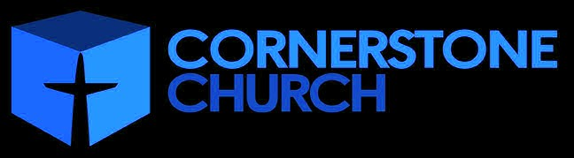

Matthew 5:1-16

Matthew 5:1-2
____________________________________________________________________________________________________________________________________________________________________________________________________________________
Matthew 7:28-29
_____________________________________________________
Numbers 6:22-26
Romans 4:7-8
_____________________________________________________

Matthew 5:3
_____________________________________________________________________________________________________________________________________________________________________________________________________________________________________________________________________________________________________________________________________________________________________________________________________________________________________________________________________________________________

Isaiah 66:2, 64:6
Romans 3:9-20
Matthew 5:48
_____________________________________________________

Romans 1:18-23,28
Luke 18:9-14
______________________________________________________________________________________________________________________________________________________________________________________________________________________________________________________________________________________________________________________________



Matthew – Jesus The King
Sovereign-Supernatural-Scriptural
Blessed/Transformed heart
Matthew 5:1-16

Matthew 5:1-16

Matthew 5:1-2
____________________________________________________________________________________________________________________________________________________________________________________________________________________
Matthew 7:28-29
_____________________________________________________
Numbers 6:22-26
Romans 4:7-8
_____________________________________________________

Matthew 5:3
_____________________________________________________________________________________________________________________________________________________________________________________________________________________________________________________________________________________________________________________________________________________________________________________________________________________________________________________________________________________________

Isaiah 66:2, 64:6
Romans 3:9-20
Matthew 5:48
_____________________________________________________

Romans 1:18-23,28
Luke 18:9-14
______________________________________________________________________________________________________________________________________________________________________________________________________________________________________________________________________________________________________________________________

Matthew 5:4
_______________________________________________________________________________________________________________________________________________________________

2 Corinthians 7:9-10
Isaiah 40:1-2
Romans 7:19-25
_____________________________________________________

Matthew 5:5
__________________________________________________________________________________________________________

Matthew 5:6
__________________________________________________________________________________________________________

1 John 3:1-3

Matthew 5:7
__________________________________________________________________________________________________________

Romans 12:14

Matthew 5:8
__________________________________________________________________________________________________________

Deuteronomy 6:5

Matthew 5:9
__________________________________________________________________________________________________________

Matthew 5:10-12
__________________________________________________________________________________________________________

Matthew 5:13-16
____________________________________________________________________________________________________________________________________________________________________________________________________________________
Matthew 5:4
_______________________________________________________________________________________________________________________________________________________________

2 Corinthians 7:9-10
Isaiah 40:1-2
Romans 7:19-25
_____________________________________________________

Matthew 5:5
__________________________________________________________________________________________________________

Matthew 5:6
__________________________________________________________________________________________________________

1 John 3:1-3

Matthew 5:7
__________________________________________________________________________________________________________

Romans 12:14

Matthew 5:8
__________________________________________________________________________________________________________

Deuteronomy 6:5

Matthew 5:9
__________________________________________________________________________________________________________

Matthew 5:10-12
__________________________________________________________________________________________________________

Matthew 5:13-16
____________________________________________________________________________________________________________________________________________________________________________________________________________________

